**05/07/2022:**

**Agenda:**

* What is web Service (or API)?
* Basic Concept behind Web Service
* Why we use it?

**Project Application:**

* Front End(UI)
* Backend(Database)
* Service(API)

**Web Service:**

* Service available over the web
* Waiter: Who is doing communication between you and kitchen
* Waiter: Waiter is performing the role of Web Service through an API
* We can Say he (Waiter) is communicating between two applications and making sure that the communication between two applications is proper.

Kitchen (Chef)(Service Provider)

You (Service Consumer)

Waiter (API)

**Web Service:**

* Service available over the web
* Enables communication between two applications over the web
* Provides a standard protocol/format for communication
* Platform independent communication
* Using Web Services two different applications can talk to each other and exchange data/information.
* An API is the acronym for Application Programming Interface, which is a software intermediary that allows two applications to talk to each other.
* Each time you use an APP like Facebook, send an instant message or check weather on your phone, you are using an API.
* Web Services allows you to expose the functionality of your existing code over the network. Once it is exposed on the network, other applications can use the functionality of your program.

**What is API?**

User Layer or Presentation Layer

Business Layer (API)

Database Layer

Client (Service Consumer)

Server (Service Provider)

Request

Response

Medium: HTTP

Format/language: XML/JSON

**Web Service:**

**Two Types of Web Service:**

* SOAP Service(Simple Object Access Protocol)
* REST Service(Representational State Transfer)

**Components/Specifications/Standards of SOAP Web Service: WSDL, UDDI, SOAP**

**WSDL: Web Service Description Language:** [**http://www.dneonline.com/calculator.asmx?WSDL**](http://www.dneonline.com/calculator.asmx?WSDL)

* WSDL stands for web service description language
* WSDL is the standard format for describing a web service
* WSDL is pronounced as ‘wiz-dull’ and spelled out as W-S-D-L
* WSDL definition describes how to access a web service and what operations it will perform.
* WSDL is often used in combination with SOAP and XML
* A Client program connecting to a web service can read the WSDL to determine what functions are available on the server.
* WSDL is an XML based document with a <definitions> element at the root and the child elements

<types>,

<message>,

<portType>,

<binding>

* Web Service description language is an XML based interface that is used to describe the functionalities of the web service

<definitions>:

* Element must be the root element of all WSDL documents
* It defines the name of the web service
* The definitions element is the container of all the other elements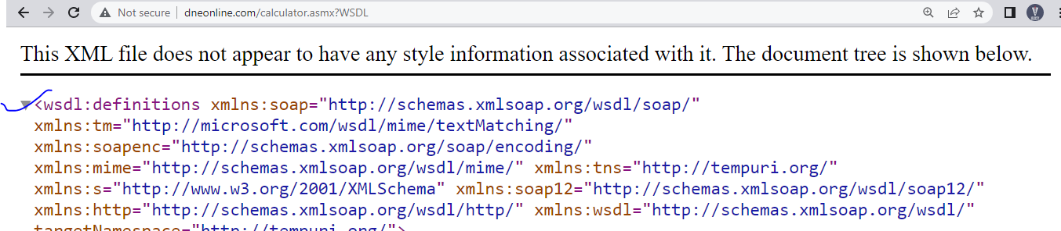

<types>:

* WSDL <types> element takes care of defining the data types that are used by the web service
* WSDL allows the types to be defined in separate elements so that the types are reusable with multiple web service

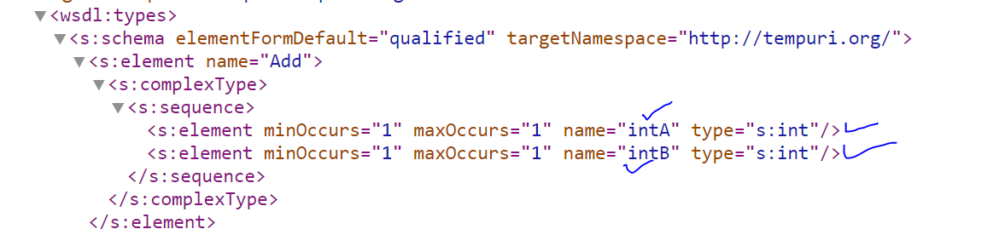

<Message>:

* The <message> element describes the data being exchanged between the web service provider and consumers.
* Each Web Service has two messages: Input and Output.

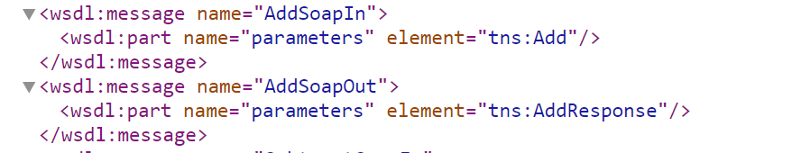

<portType>:

* <portType> can combine one request and one response message into a single request response operation. 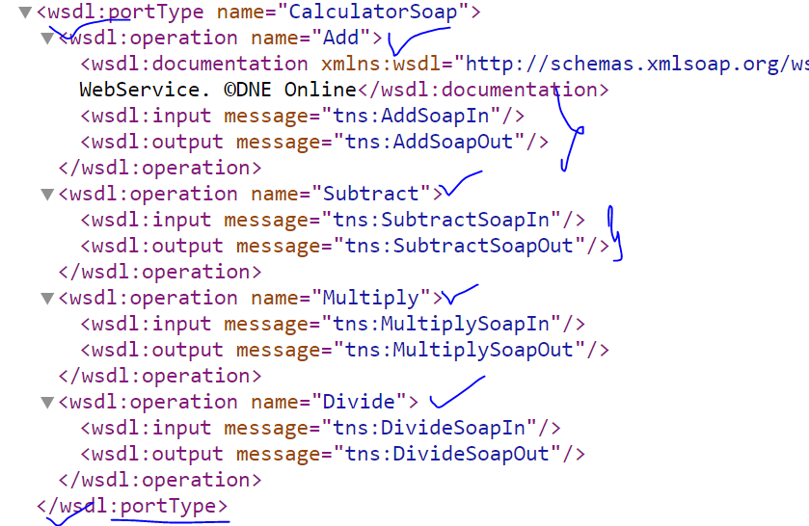

<binding>:

* To Combine all operations together
* The <binding> element provides specific details on how a port type operation will actually be transmitted over the web. 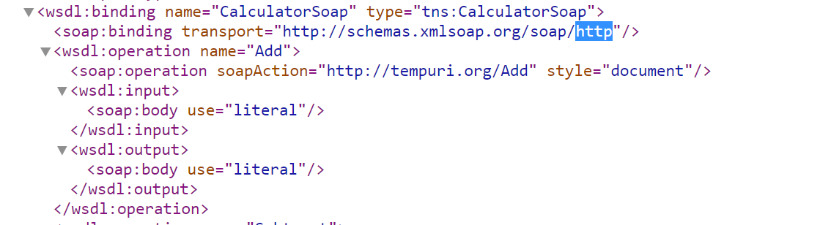

WSDL File/Service: <defintions>,<types>,<message>,<portType>,<binding>

**UDDI: Universal Description Discovery Integrations**

* Universal description discovery integration is an XML based standard for publishing and finding web services
* A web service provider publishes his web service(through WSDL) on an online directory from where consumers can query and search the web service
* This is online registry/directory

WSDL

WSDL

WSDL

WSDL

UDDI

# SOAP Web Service:

* A web service that follows SOAP web service specifications is a SOAP service.

What are these specifications/Standards?

* Basic Specifications: WSDL,UDDI,SOAP

Who defines and dictates these specifications?

* W3C(World Wide Web Consortium)

### SOAP: Simple Object Access Protocol

* SOAP is an XML based protocol for exchanging information between web services
* SOAP is communication protocol
* SOAP provides data transport for web services
* All the information exchange happens over the common format: **XML**
* XML message has a defined structure: **SOAP Message**
* SOAP Message Consists of: **Envelope, Header, Body, Fault**

**Envelope** :( **Mandatory**)

* The SOAP envelope indicates the start and end of the message so that the receiver knows when an entire message has transmitted
* The SOAP Envelope solves the problem of knowing when you are done receiving a message and are ready to process it.
* Every SOAP Message has a root Envelope Element
* Envelope element is mandatory part of SOAP Message.

**Header** :( **Optional**)

* Contains any optional attributes of the message used in processing the message, either at an intermediary point or at the ultimate end point

**Body**: (**Mandatory**)

* Contains XML data comprising the message being sent
* The SOAP Body is a mandatory element which contains the application defined XML data being exchanged in a SOAP Message
* The body must be contained within the envelope and must follow any headers that might be defined for the message

**Fault**: (**Optional**)

* An optional fault element that provides information about errors that occurred while processing the message
* When an error occurs during processing, the response to a SOAP message is a SOAP fault element in the body of the message and the fault is returned to the sender of the SOAP Message.

**SOAP Message:**

<soapenv:Envelope xmlns:soapenv="http://schemas.xmlsoap.org/soap/envelope/" xmlns:tem="http://tempuri.org/">

<soapenv:Header/>

<soapenv:Body>

<tem:Add>

<tem:intA>A</tem:intA>

<tem:intB>9</tem:intB>

</tem:Add>

</soapenv:Body>

</soapenv:Envelope>

**SOAP Fault:**

<soap:Envelope xmlns:soap="http://schemas.xmlsoap.org/soap/envelope/" xmlns:xsi="http://www.w3.org/2001/XMLSchema-instance" xmlns:xsd="http://www.w3.org/2001/XMLSchema">

<soap:Body>

<soap:Fault>

<faultcode>soap:Client</faultcode>

<faultstring>System.Web.Services.Protocols.SoapException: Server was unable to read request. ---> System.InvalidOperationException: There is an error in XML document (5, 32). ---> System.FormatException: Input string was not in a correct format.

at System.Number.StringToNumber(String str, NumberStyles options, NumberBuffer&amp; number, NumberFormatInfo info, Boolean parseDecimal)

at System.Number.ParseInt32(String s, NumberStyles style, NumberFormatInfo info)

at System.Xml.XmlConvert.ToInt32(String s)

at Microsoft.Xml.Serialization.GeneratedAssembly.XmlSerializationReader1.Read1_Add()

at Microsoft.Xml.Serialization.GeneratedAssembly.ArrayOfObjectSerializer.Deserialize(XmlSerializationReader reader)

at System.Xml.Serialization.XmlSerializer.Deserialize(XmlReader xmlReader, String encodingStyle, XmlDeserializationEvents events)

--- End of inner exception stack trace ---

at System.Xml.Serialization.XmlSerializer.Deserialize(XmlReader xmlReader, String encodingStyle, XmlDeserializationEvents events)

at System.Xml.Serialization.XmlSerializer.Deserialize(XmlReader xmlReader, String encodingStyle)

at System.Web.Services.Protocols.SoapServerProtocol.ReadParameters()

--- End of inner exception stack trace ---

at System.Web.Services.Protocols.SoapServerProtocol.ReadParameters()

at System.Web.Services.Protocols.WebServiceHandler.CoreProcessRequest()</faultstring>

<detail/>

</soap:Fault>

</soap:Body>

</soap:Envelope>

# API Testing-

* 2 Types Service

1. SOAP service(SOAP UI tool)
2. REST service(SOAP UI,POSTMAN)

Paytm – UI/ GUI

**Service Travels**- Parameter Values

Travels agency/ Provide-**Service/**

**IRCTC - Service**

Request

Response

IRCTC main Server

### SOAP UI TOOL:

<https://www.soapui.org/downloads/soapui/>

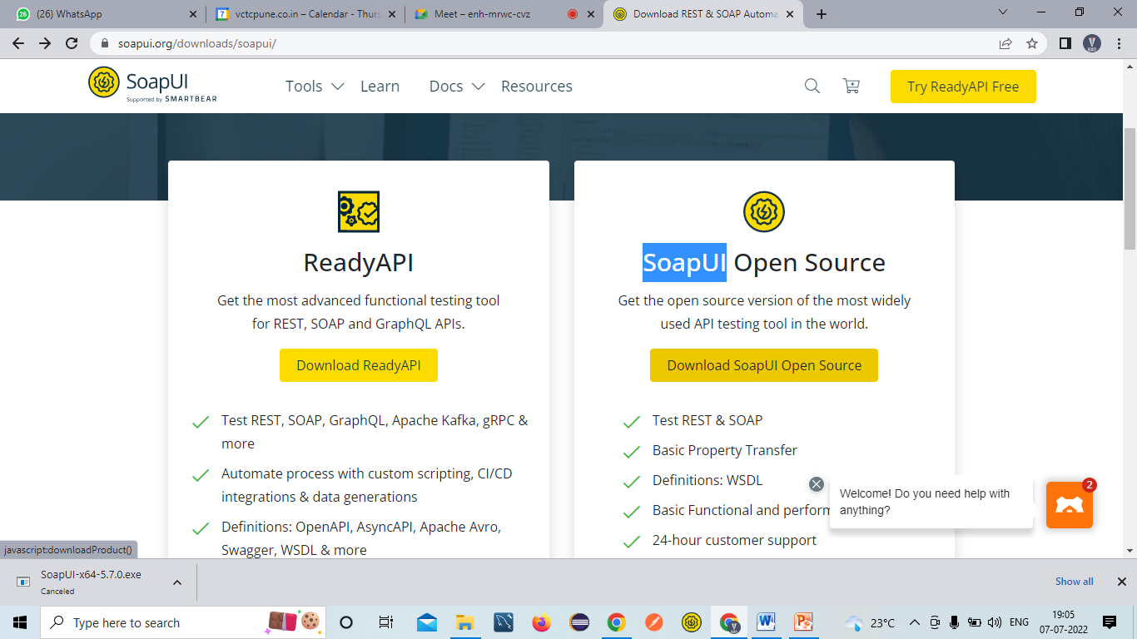

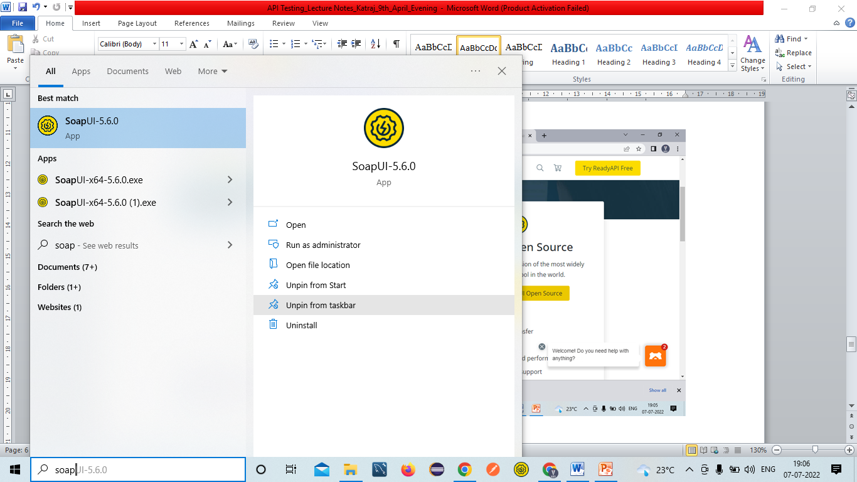 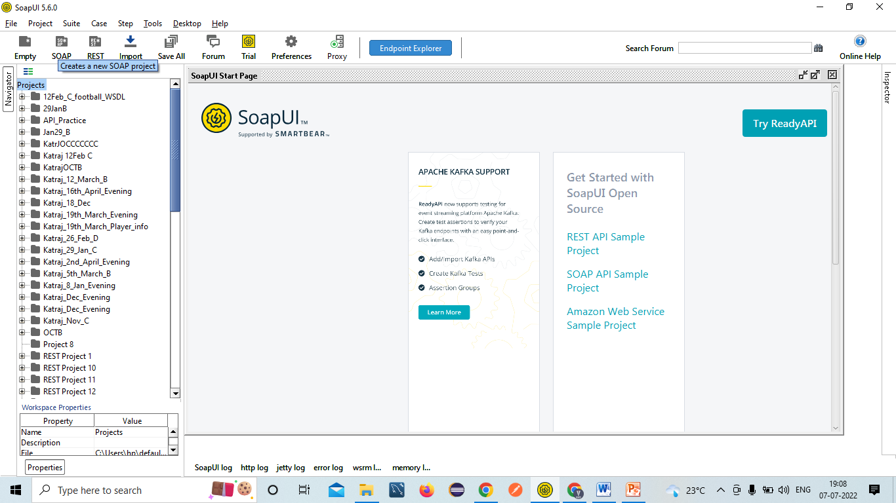 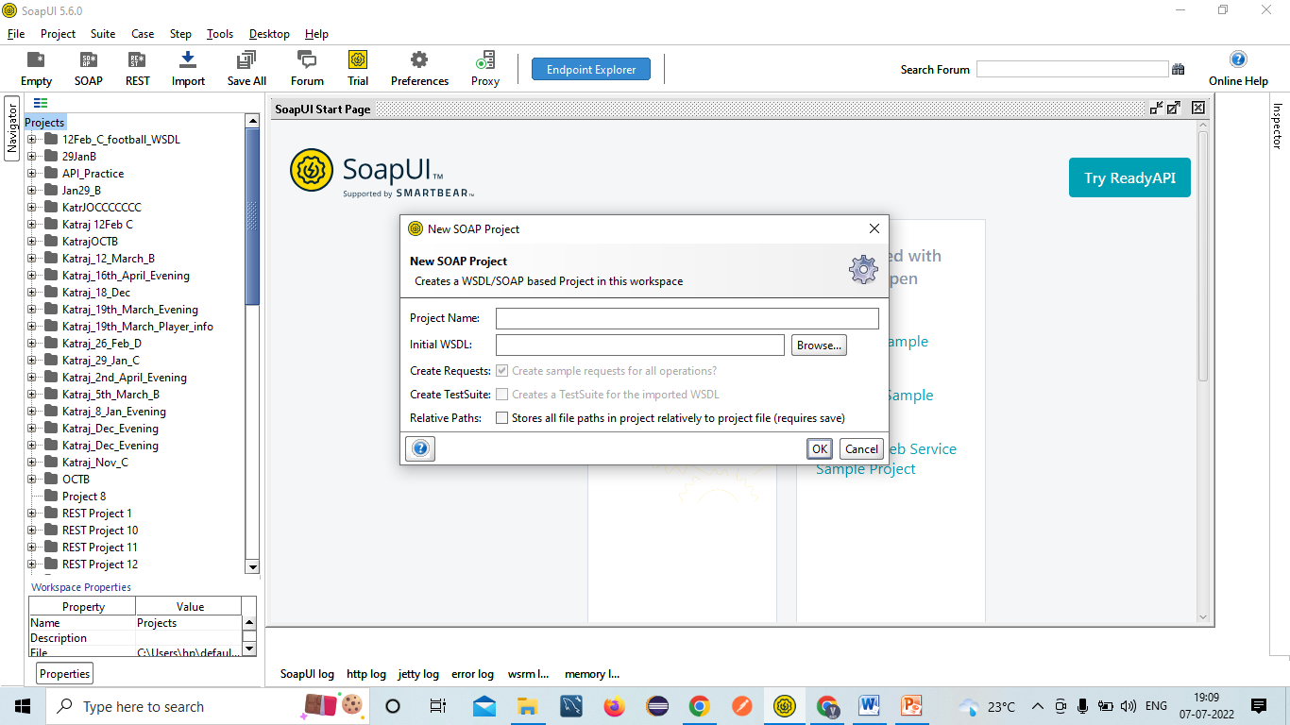 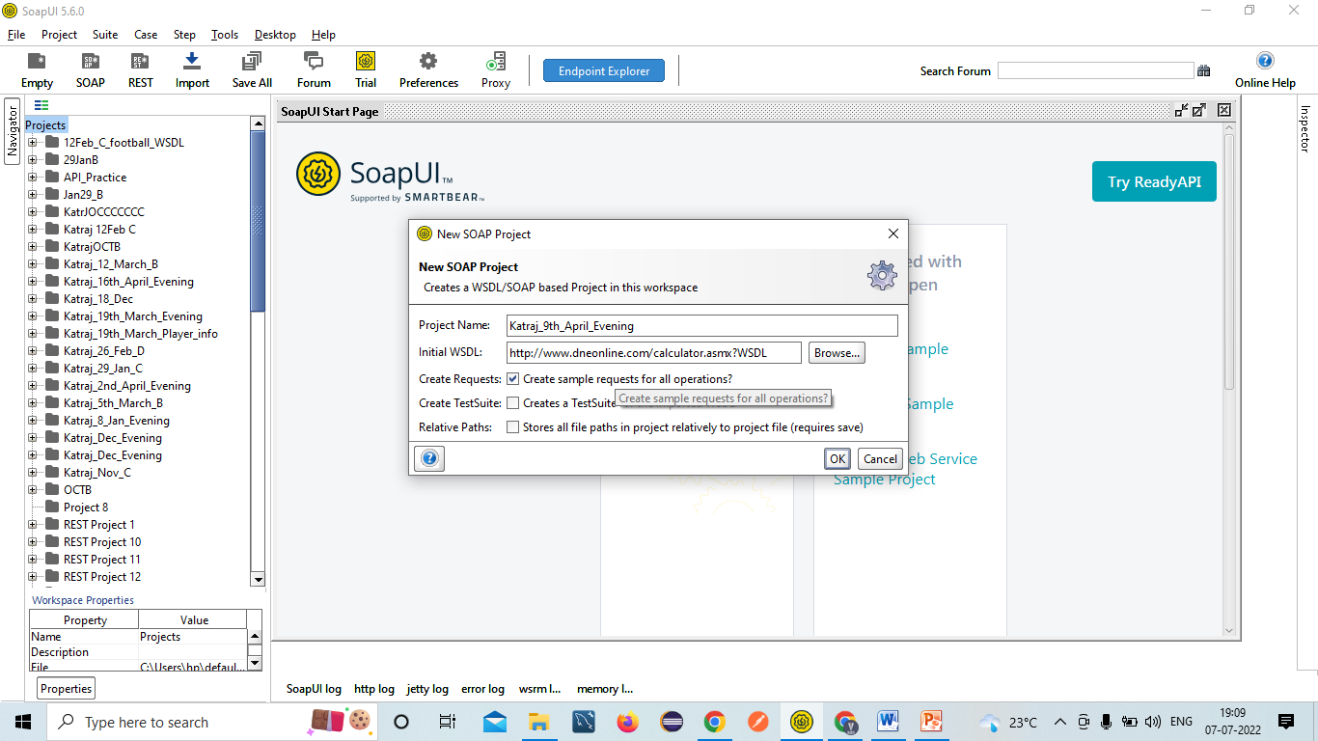 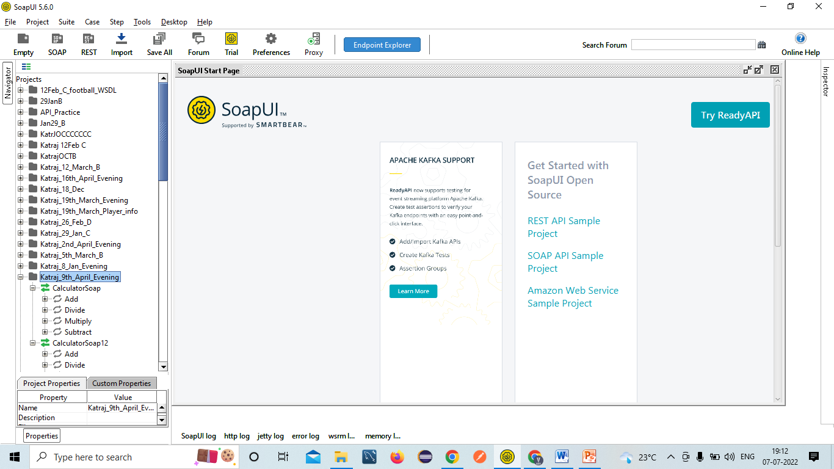 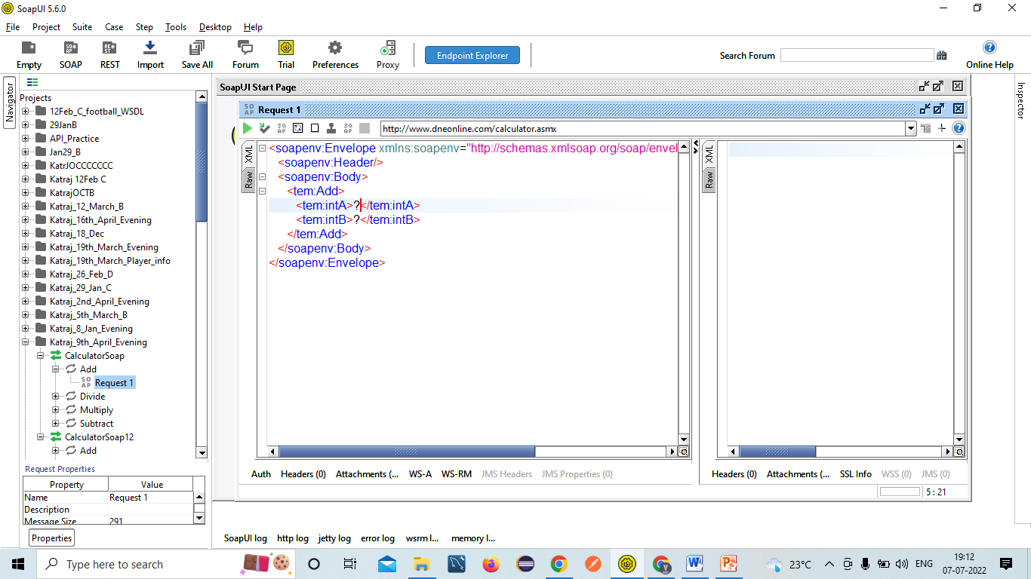 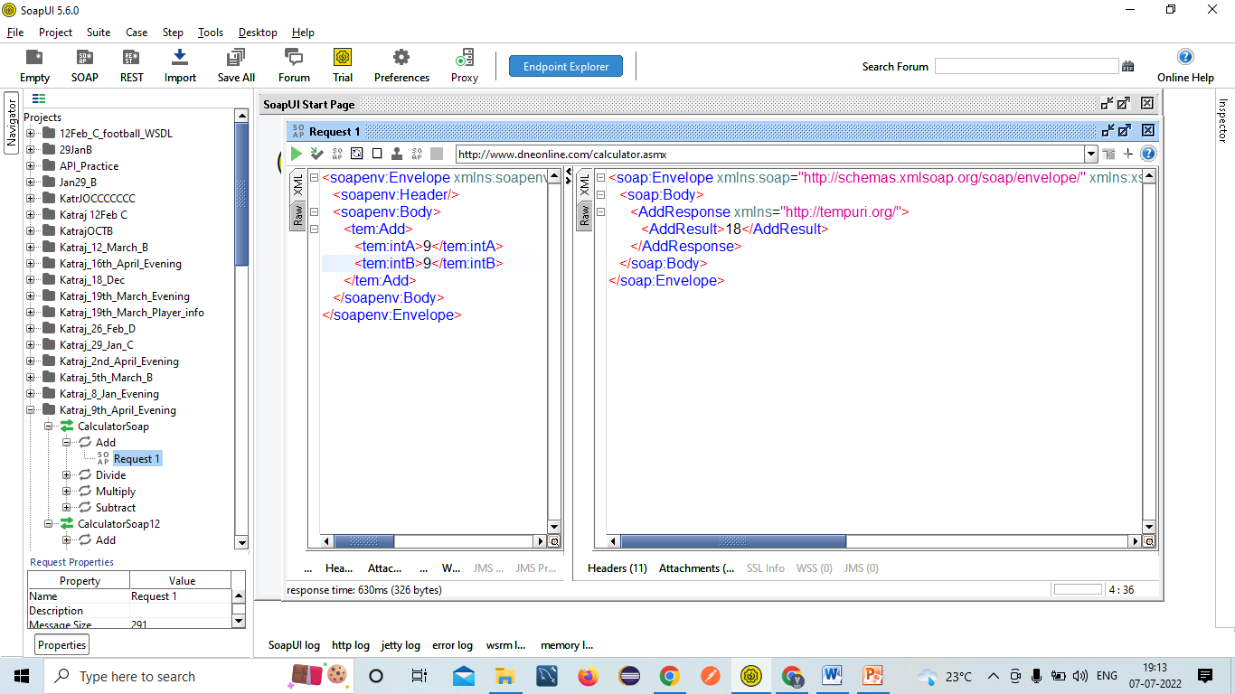

### SOAP Web Service:

* Developer will provide WSDL file: <http://www.dneonline.com/calculator.asmx?WSDL>
* Unit Testing document: Screenshots, Tables, Sample Request, Sample Response, Response Code etc
* Time Taken for the response🡺5Secs
* Authorization Details: Basic Auth(Username & Password)

**Test Cases:**

1. Validating SOAP Response=Pass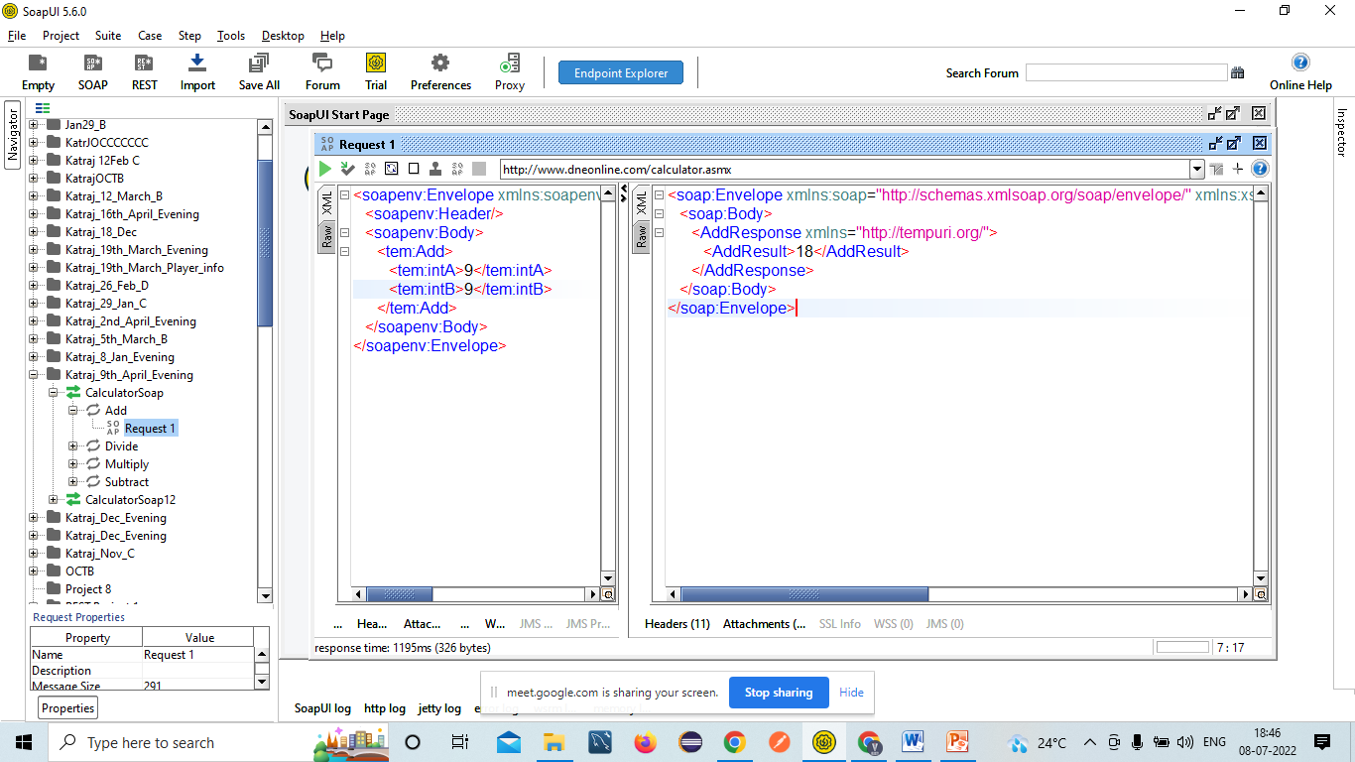

2. Validating data and count of data present in the SOAP response=Pass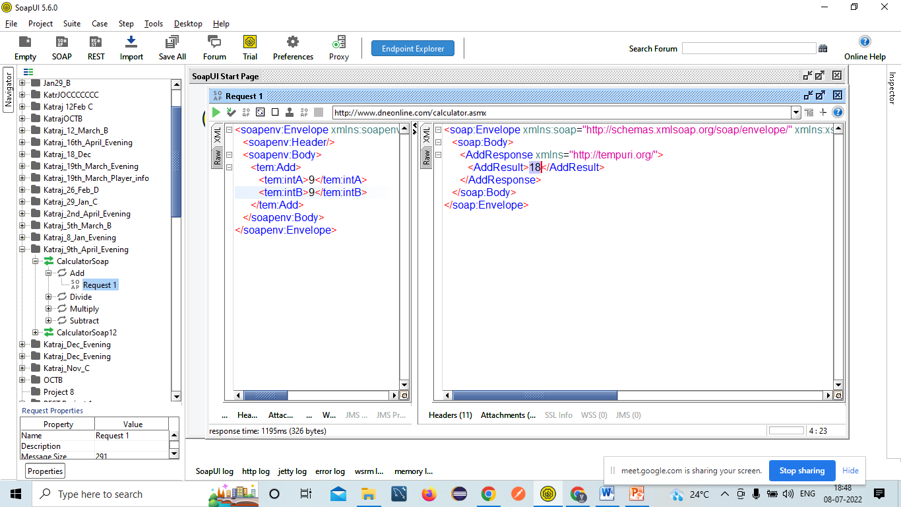

3. Validating tag names/Attributes present in the response🡺EC=Tagname should contain AddResult=Pass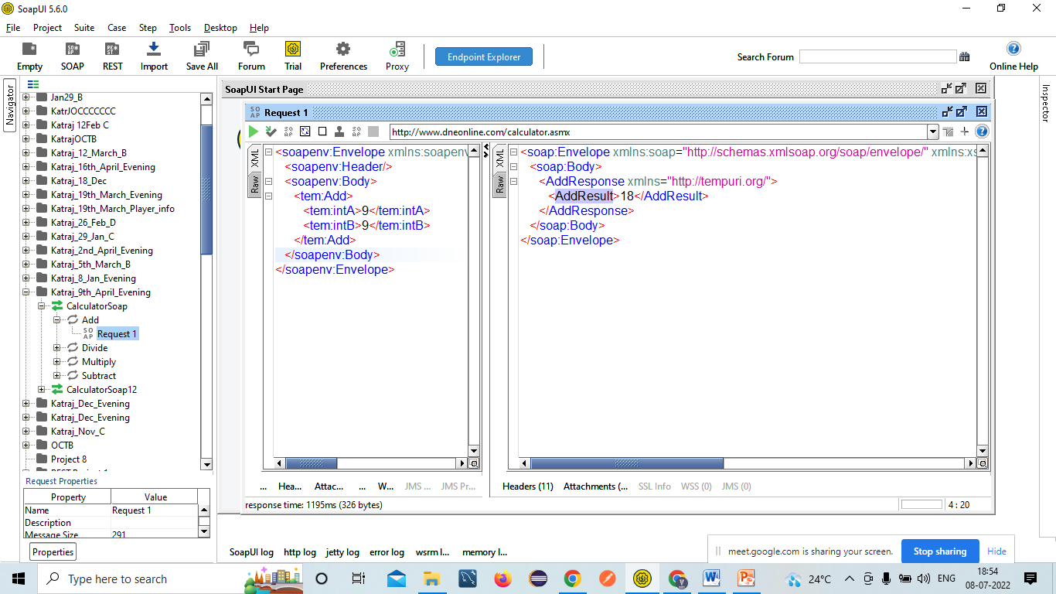

4. Validating different status codes present in the response🡺EC=200-OK=Pass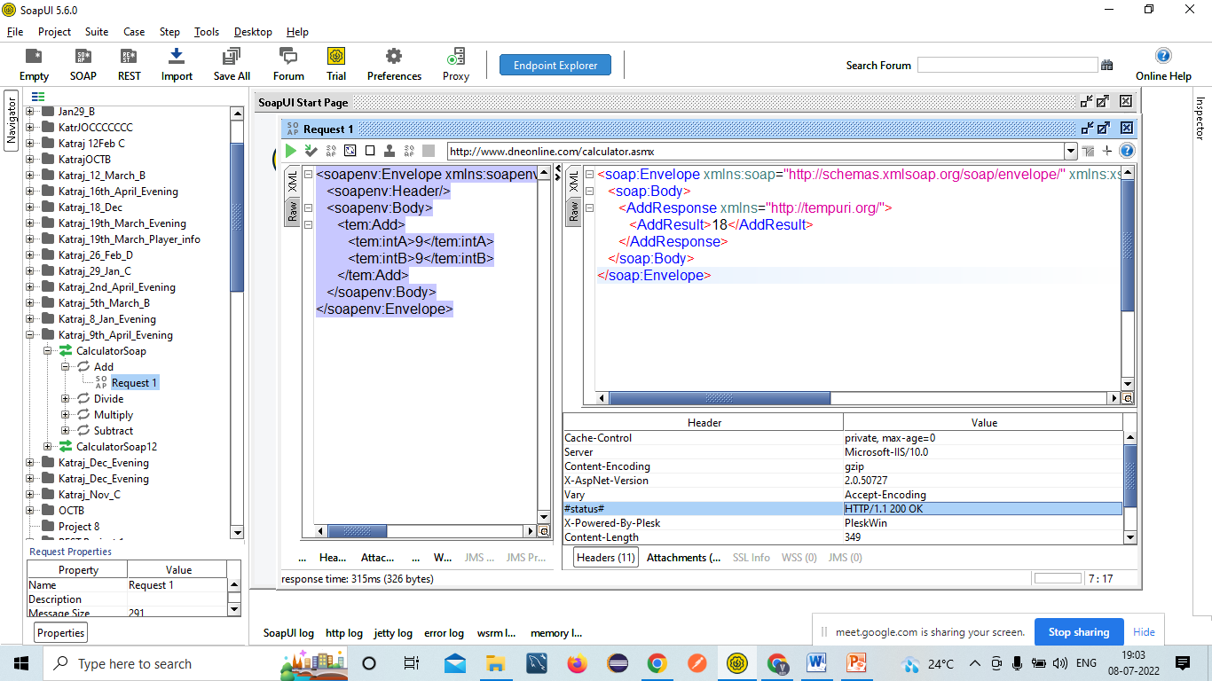

5. Validating time taken for the response🡺EC=5Secs=Pass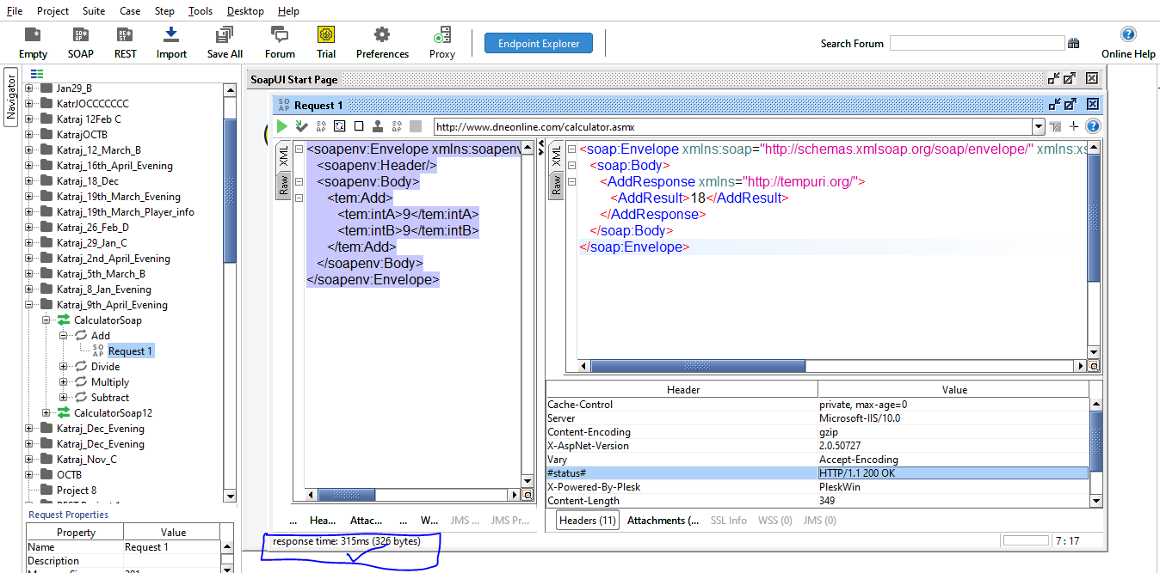

6. Applying **Assertion** for Verification (Validation Point)🡺To Compare Actual result VS Expected Result🡺We have to create Test Suite to apply Assertion🡺Right Click on Folder and then click on Generate Test Suite Option. 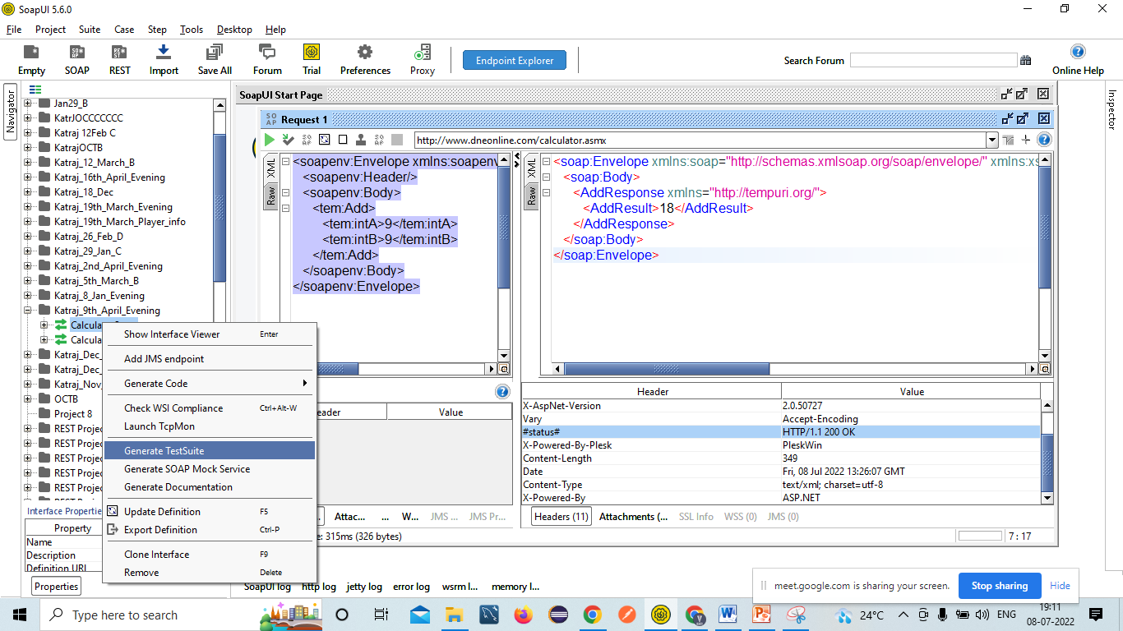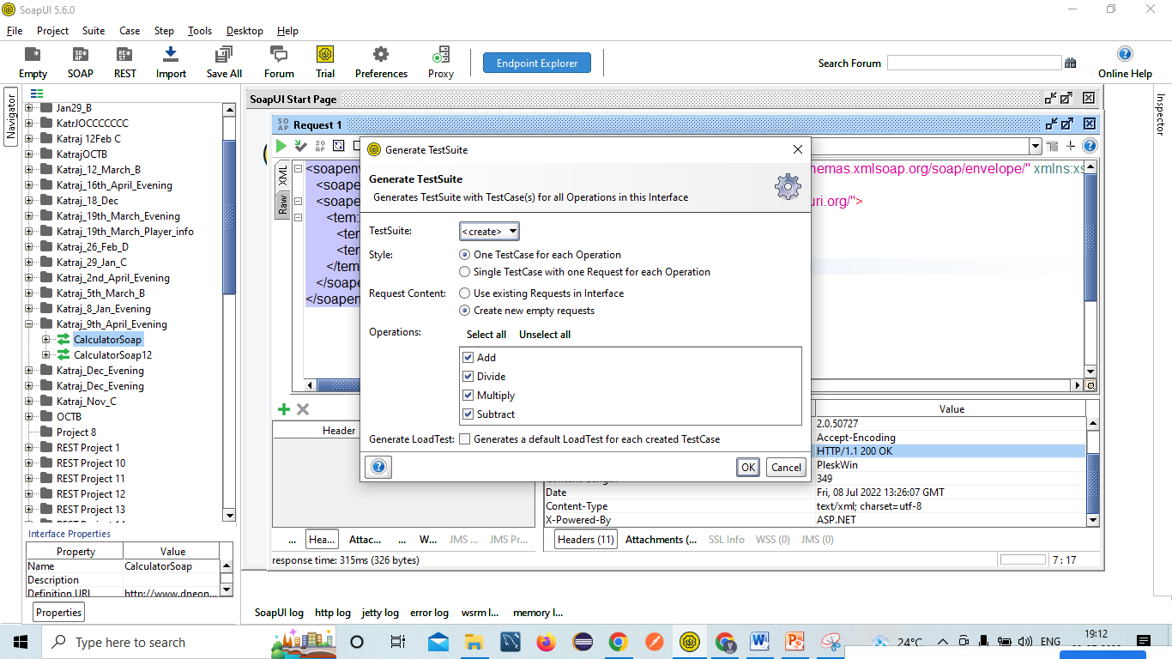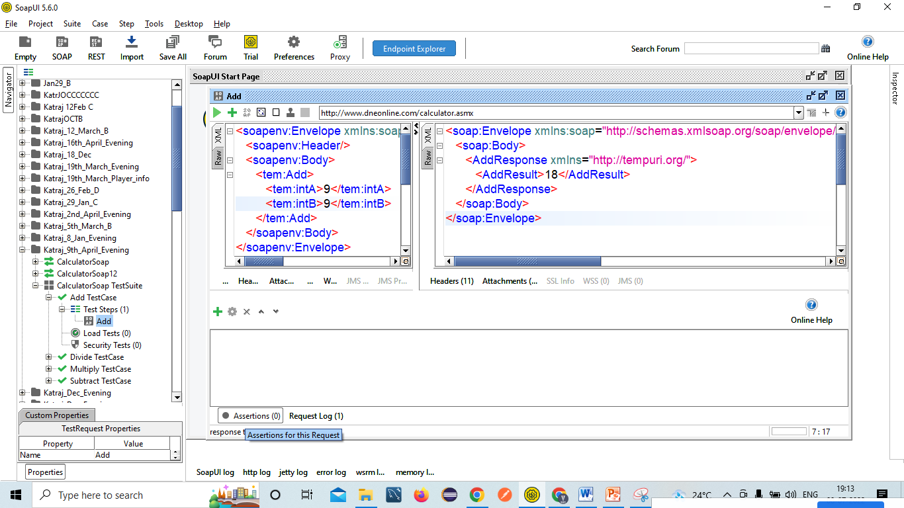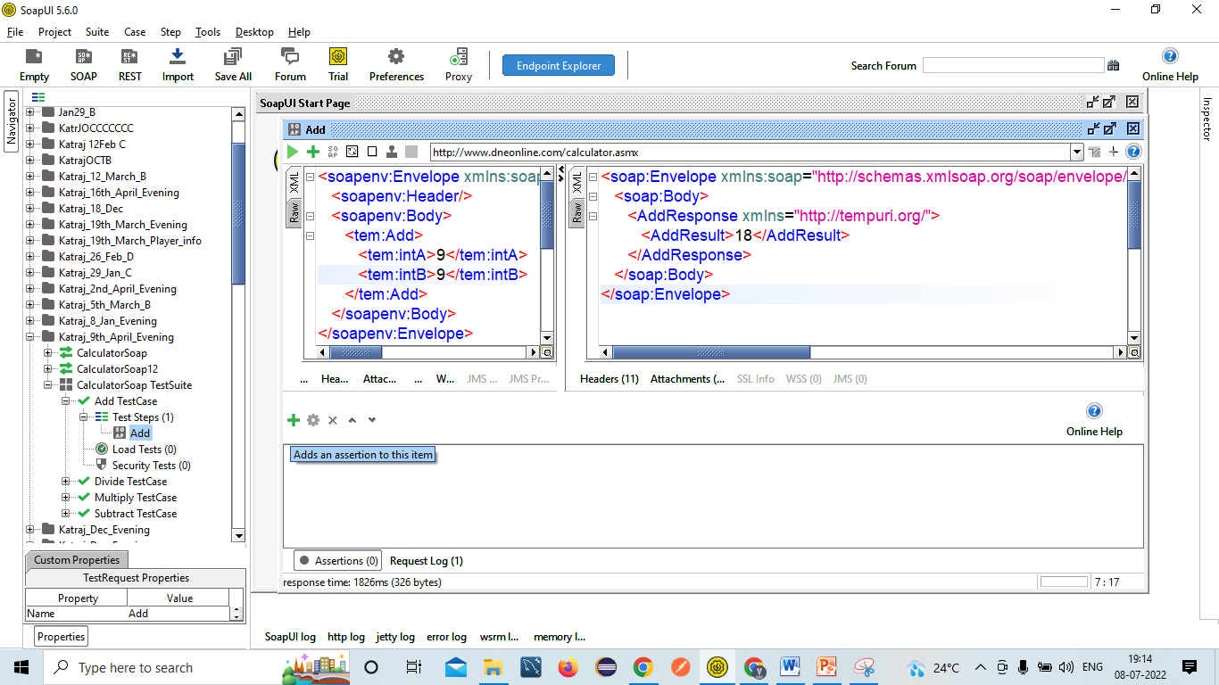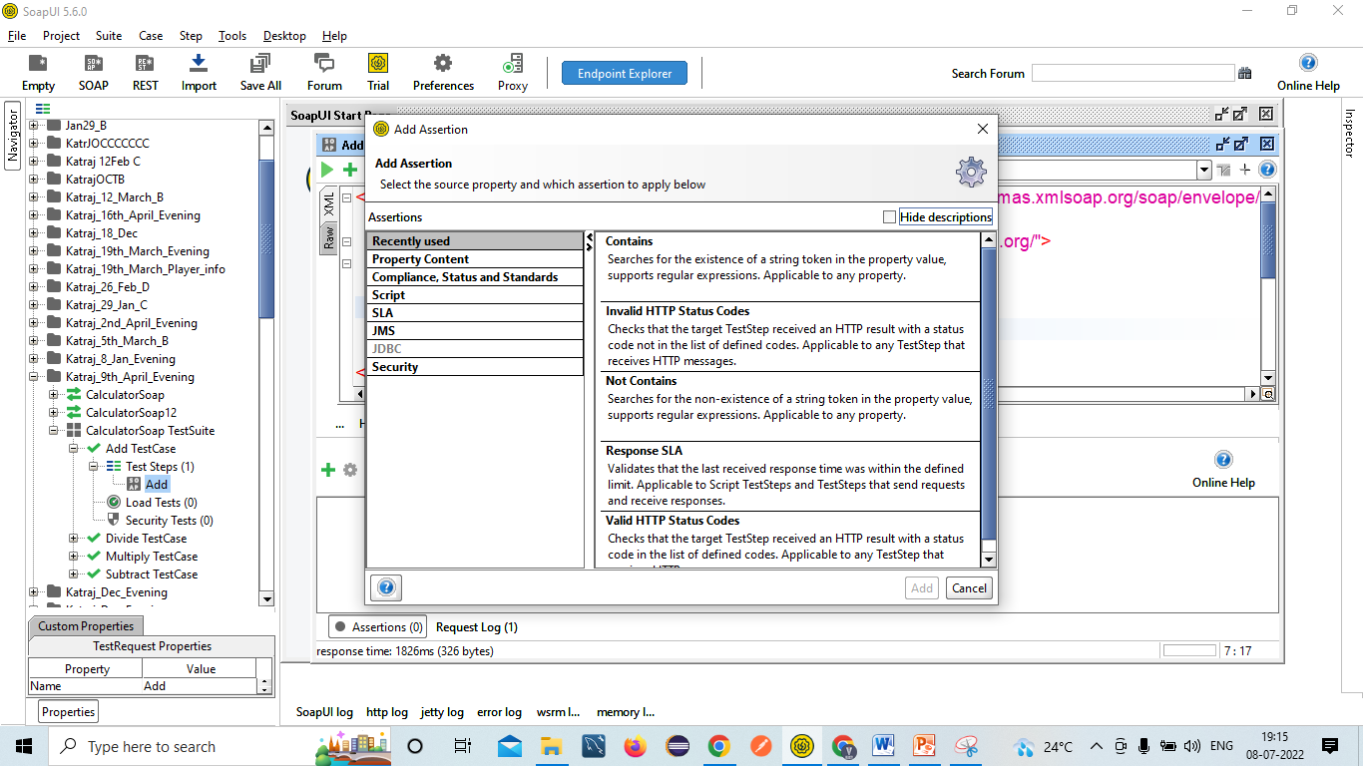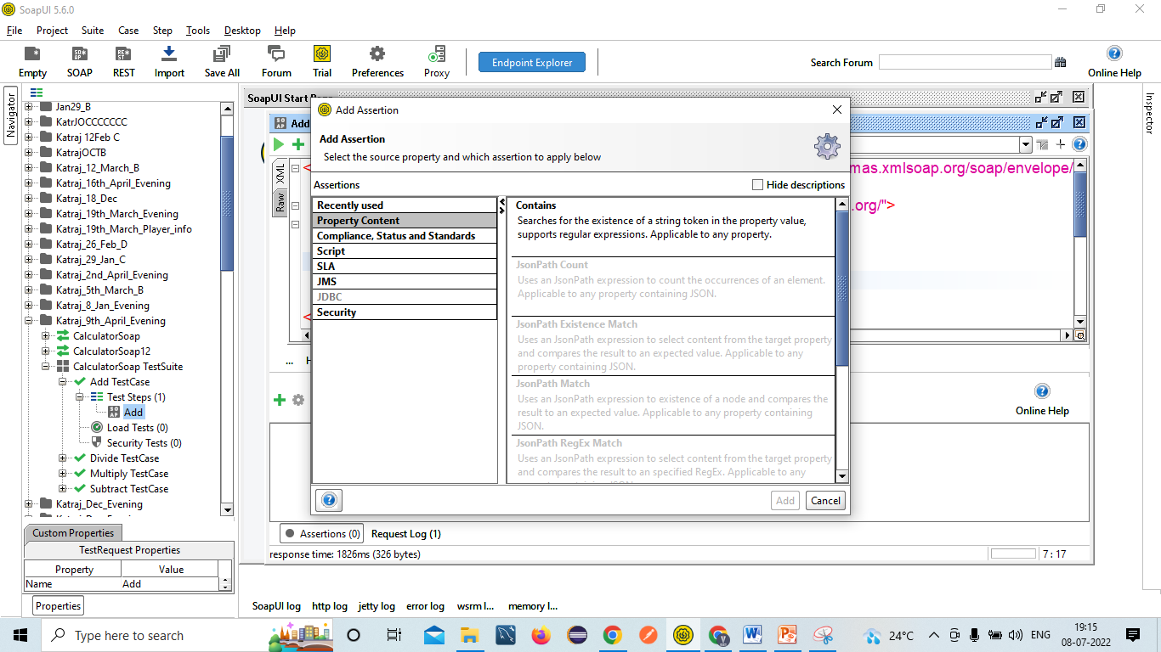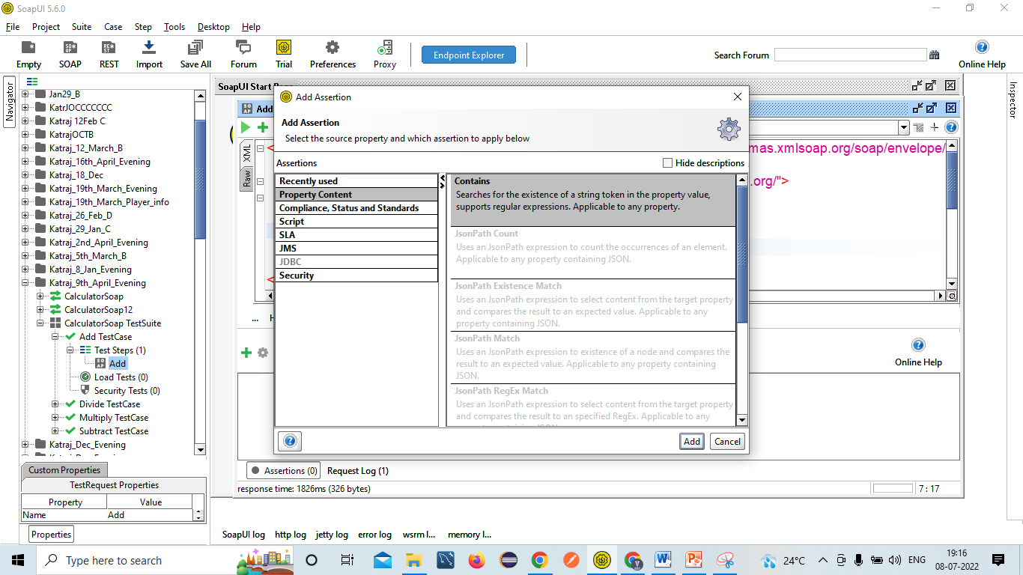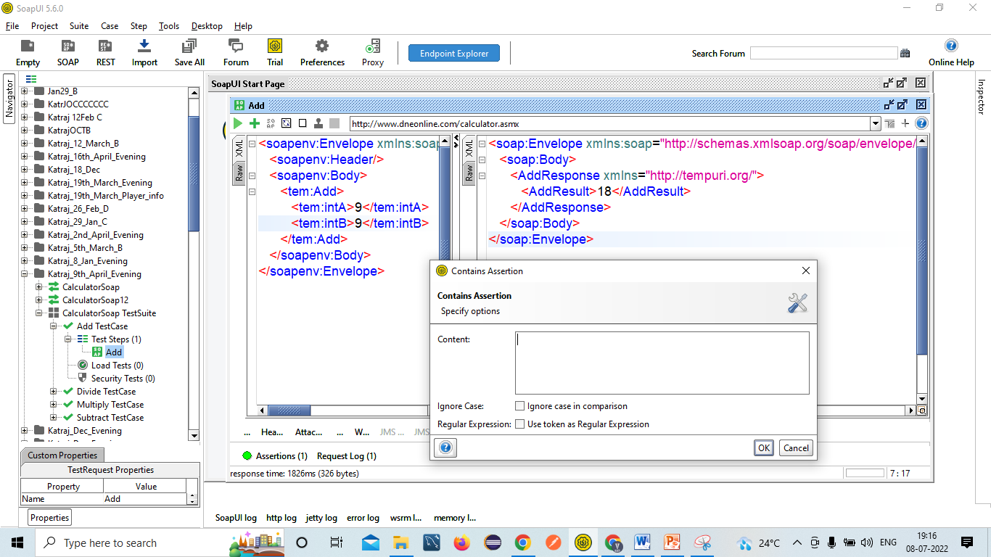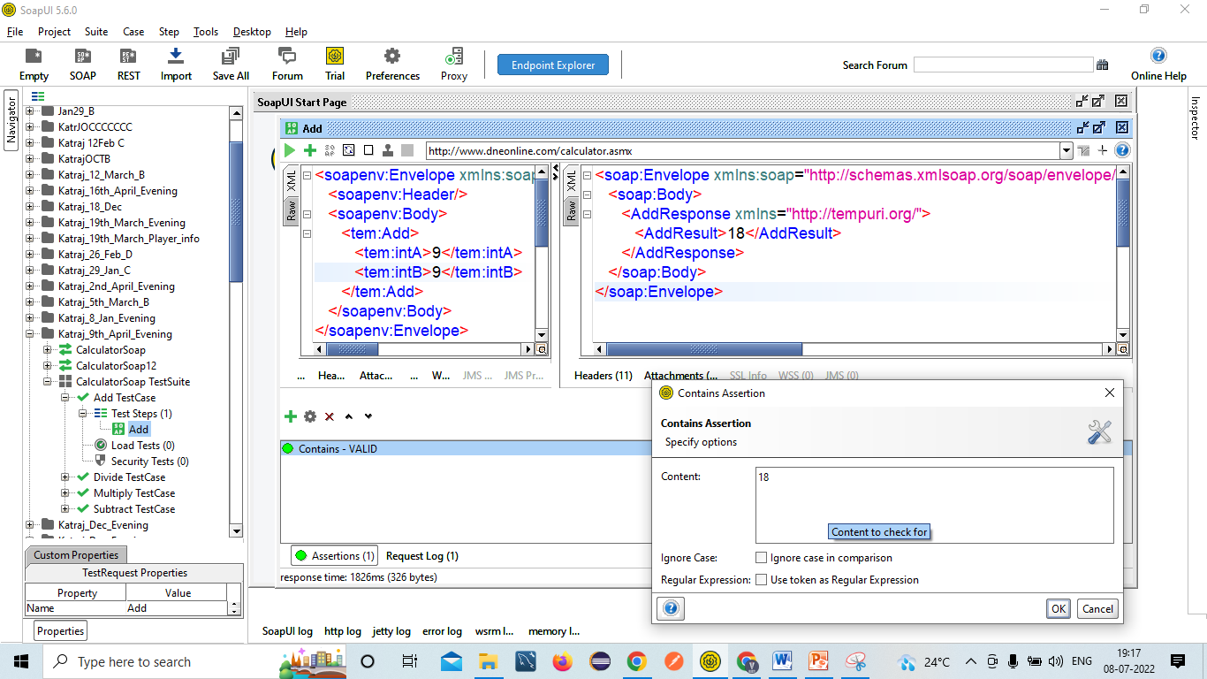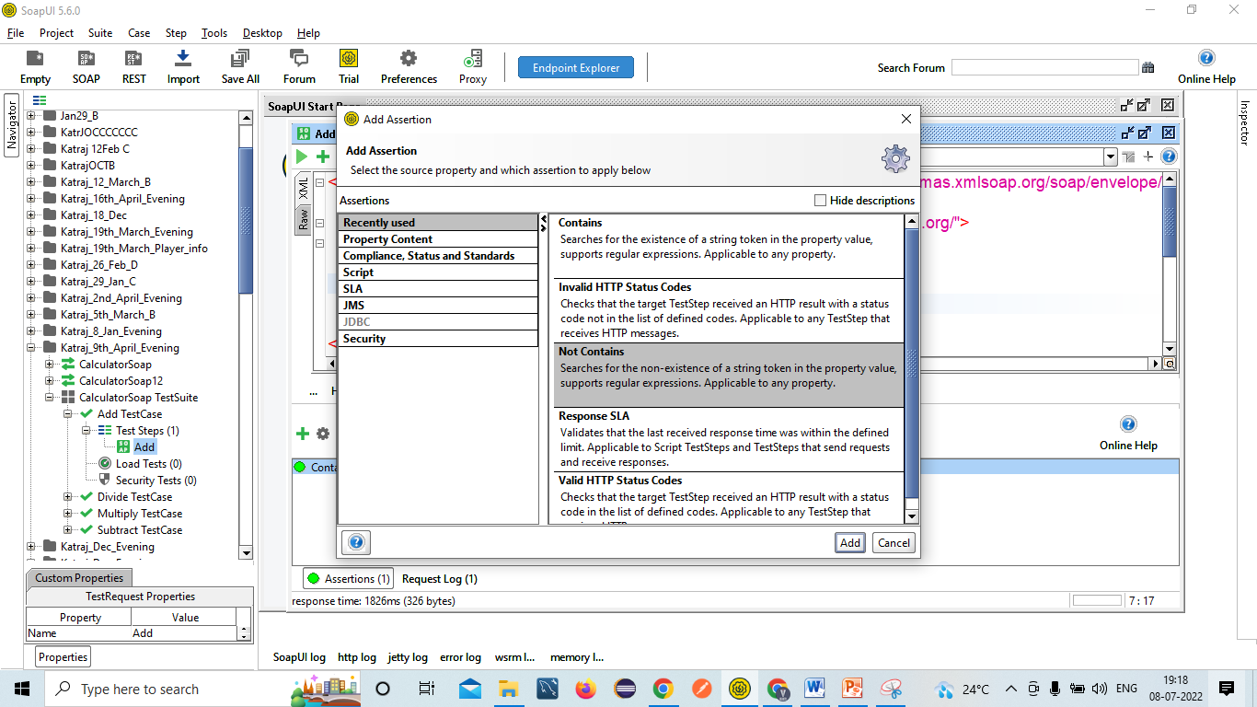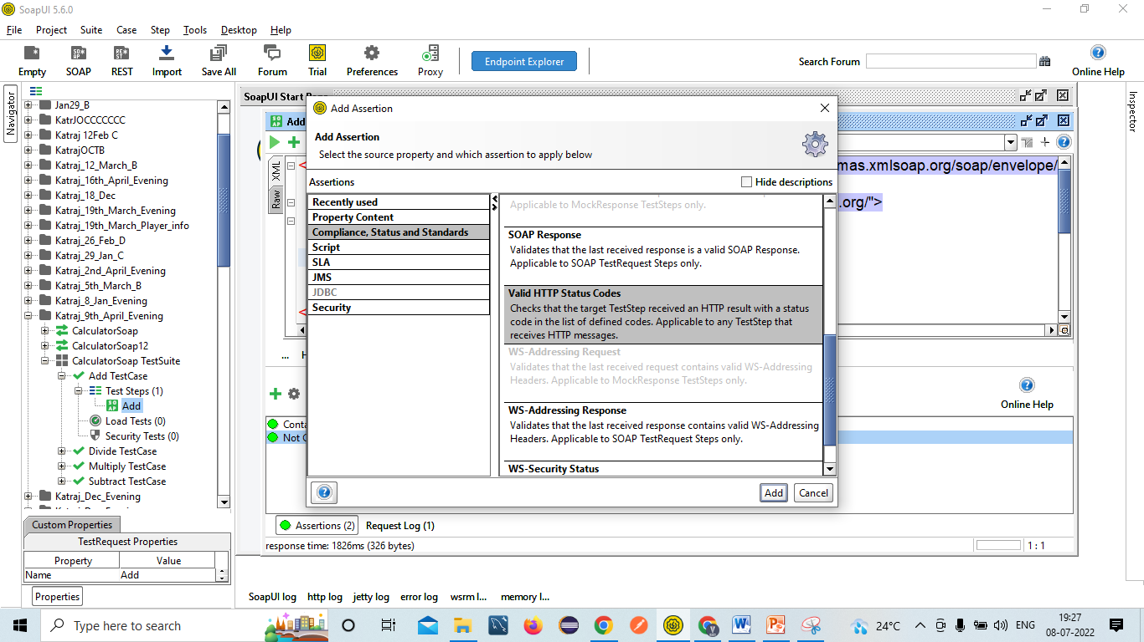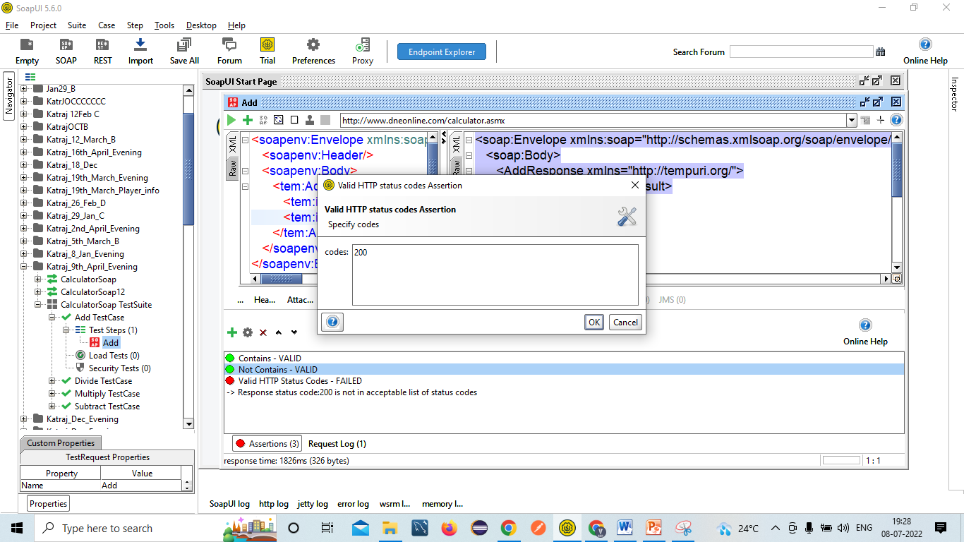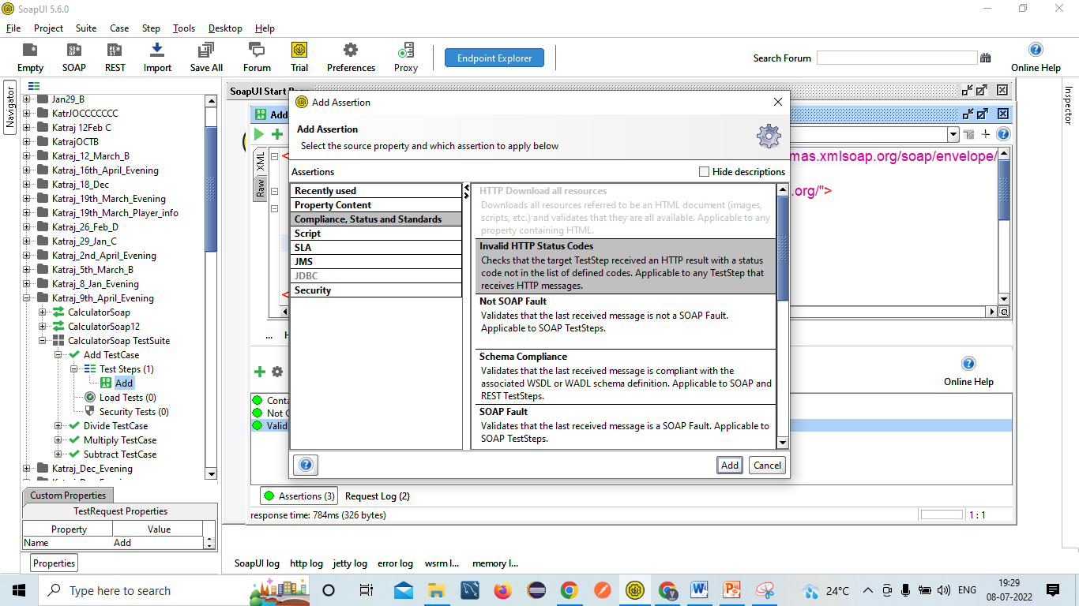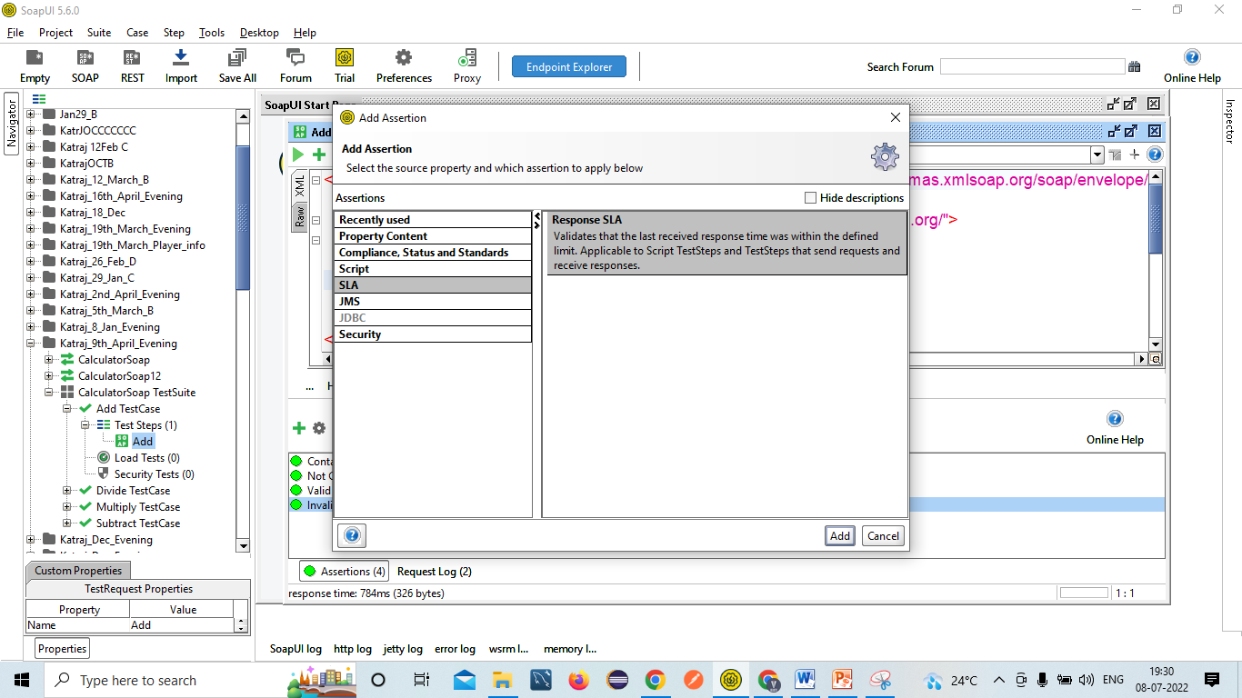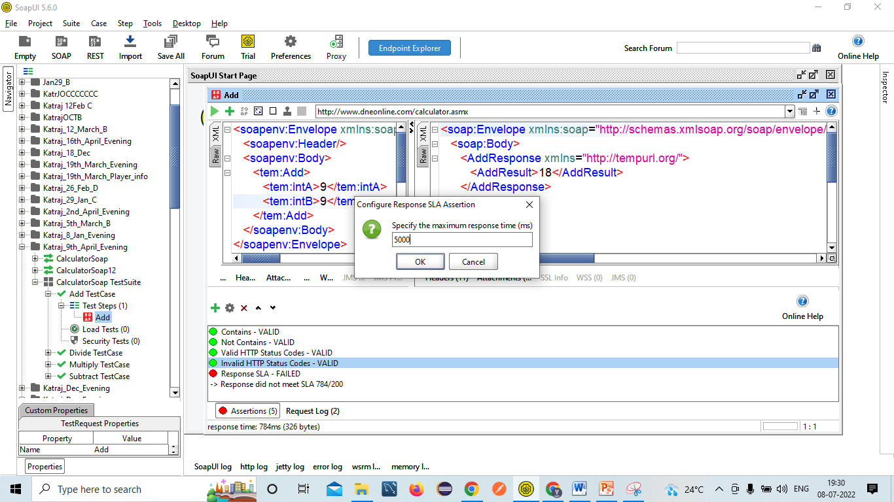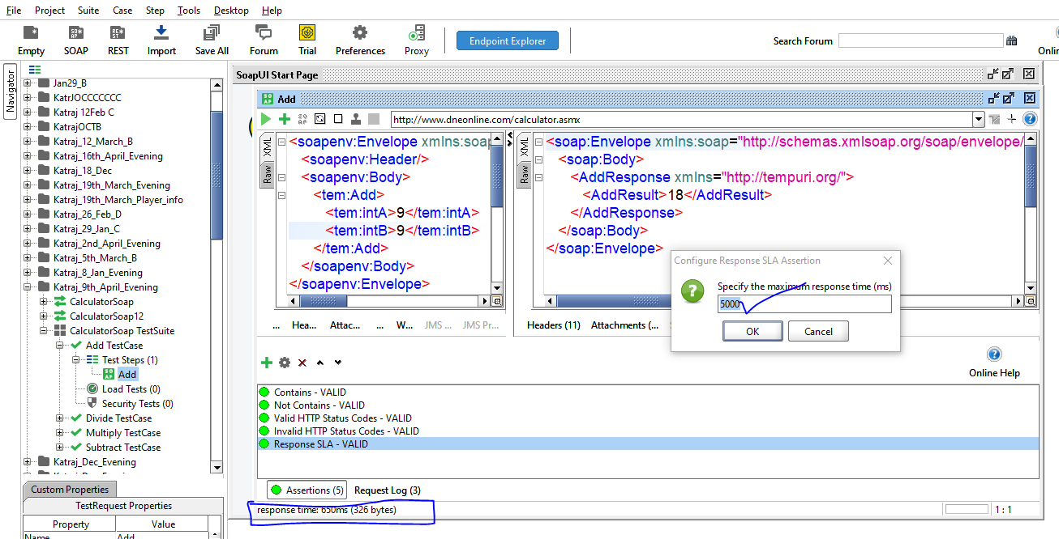

7. Validating functionality by passing Test Data(Re-Testing)

7.1 Verify the SOAP Service by passing one digit numbers🡺EC=One digit numbers should be added=Pass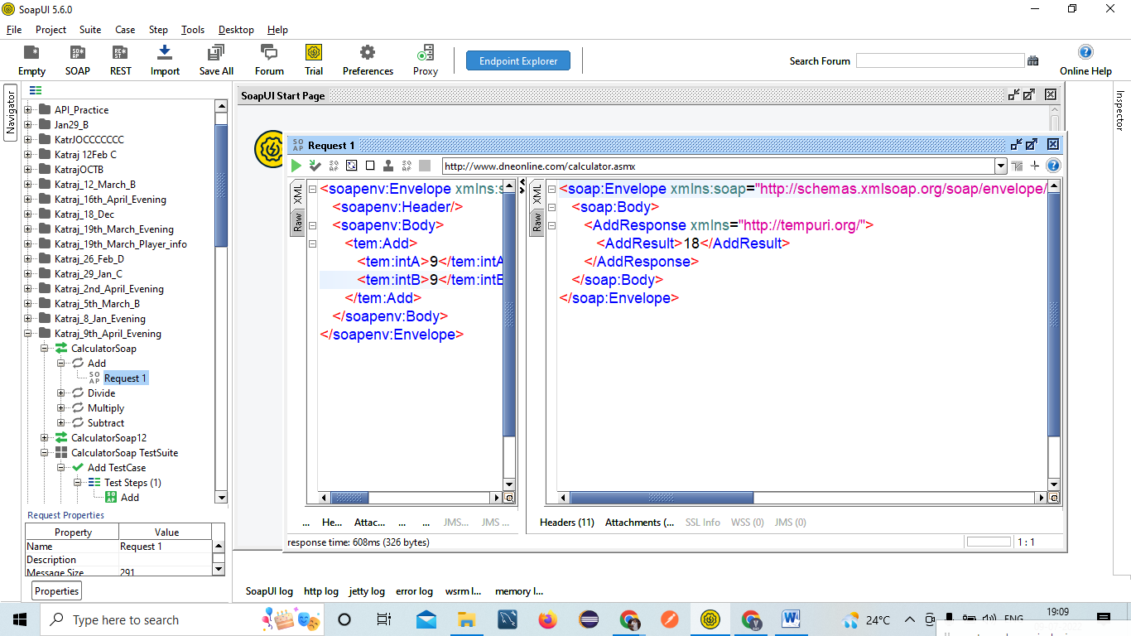

7.2 Verify the SOAP Service by passing two digit numbers🡺EC=Two digit numbers should be added=Pass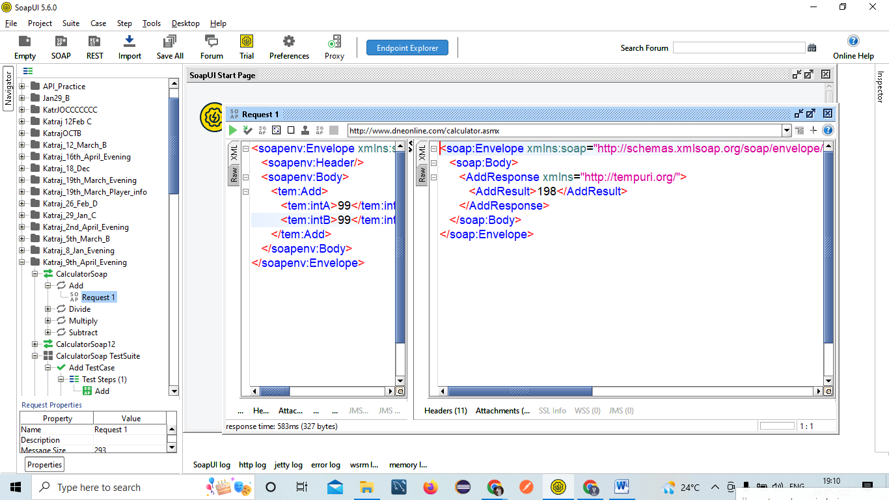

7.3 Verify the SOAP Service by passing Four/Five digit numbers🡺EC=Four/Five digit numbers should be added=Pass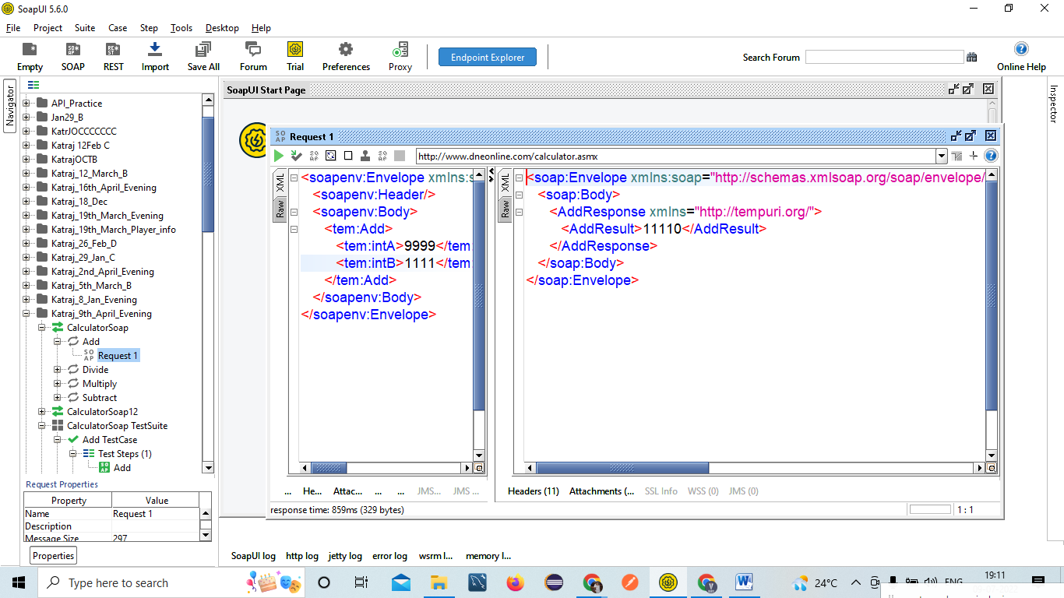

7.4 Verify the SOAP Service by passing one digit number at 1st place and two digit number at 2nd place🡺EC= one digit number at 1st place and two digit number at 2nd place should be added=Pass 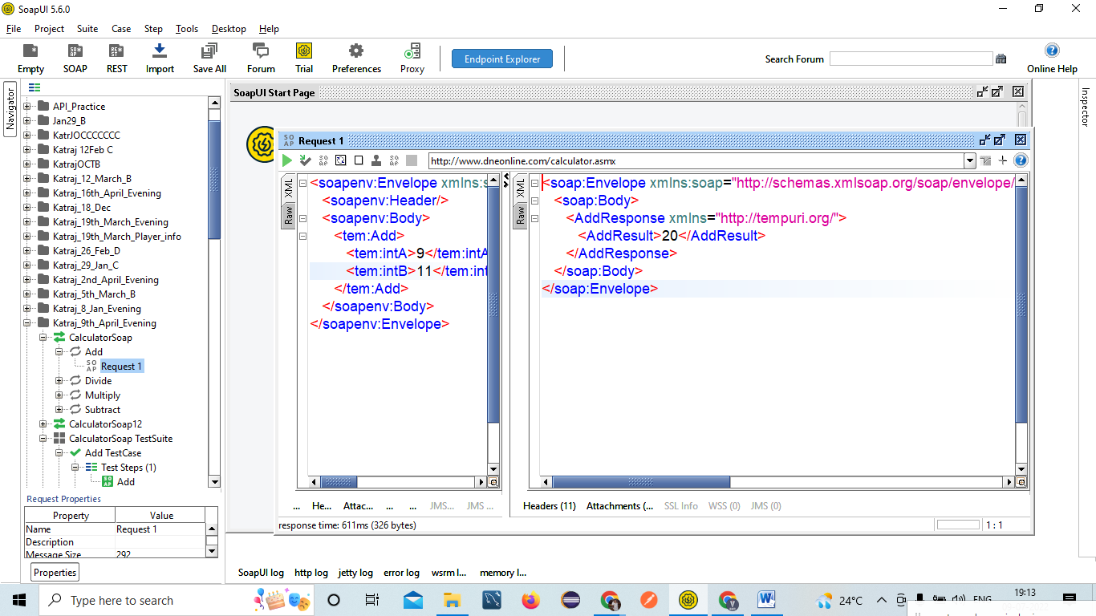

7.5 Verify the SOAP Service by passing zero numbers🡺EC=Zero numbers should be added=Pass 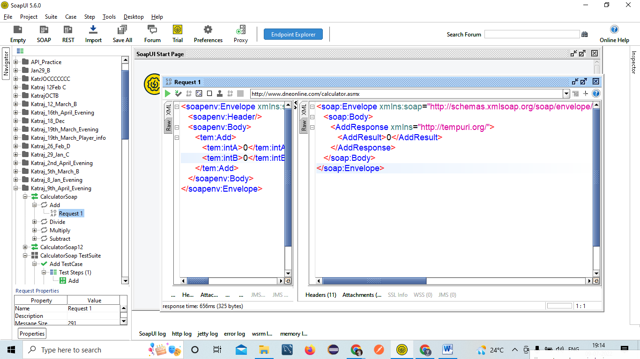

7.6 Verify the SOAP Service by passing both digits as –Ve numbers🡺EC=Negative numbers should be added=Pass 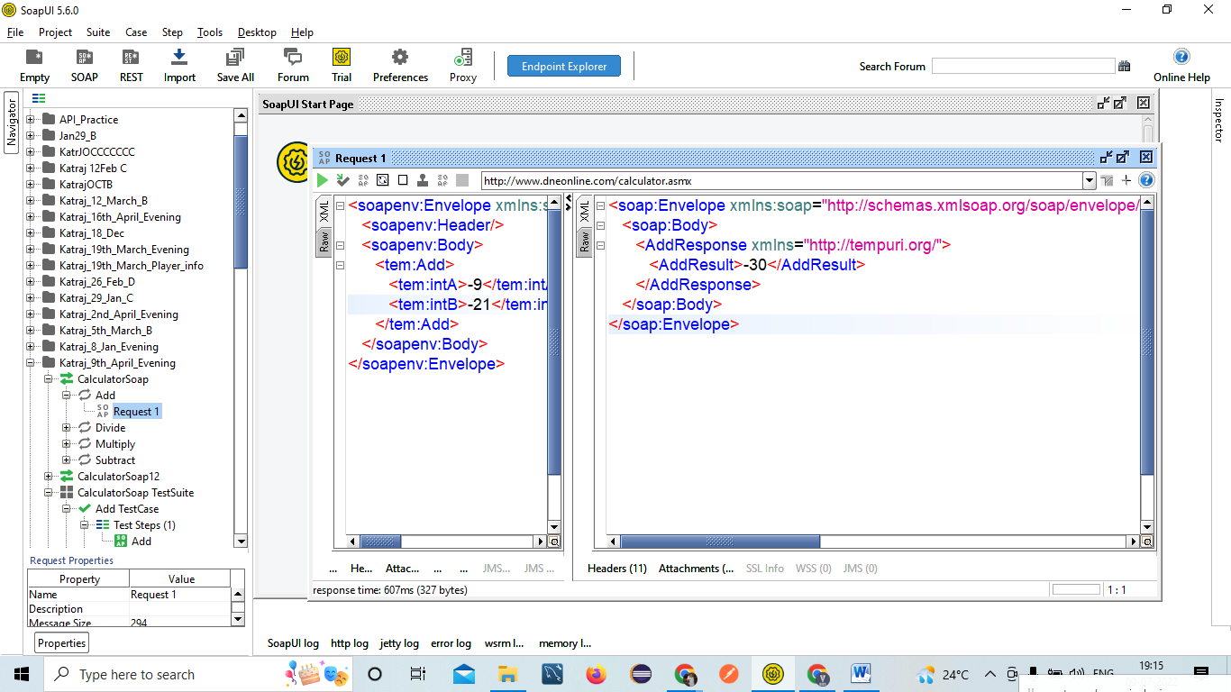

8.Validating Negative Test Cases!

8.1 Verify the SOAP Service by passing decimal digit numbers🡺EC=Decimal digit numbers should not be added=Pass 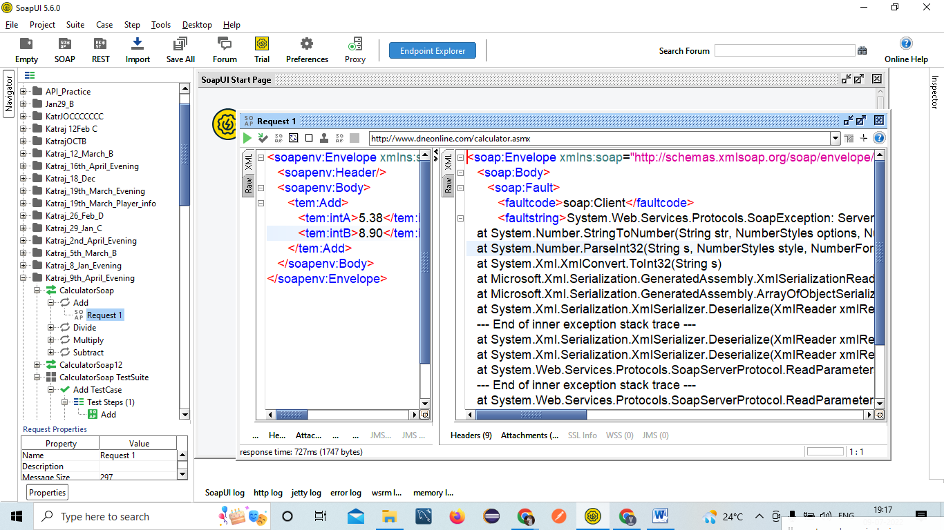

8.2 Verify the SOAP Service by passing String/Character🡺EC=Should not be added=Pass 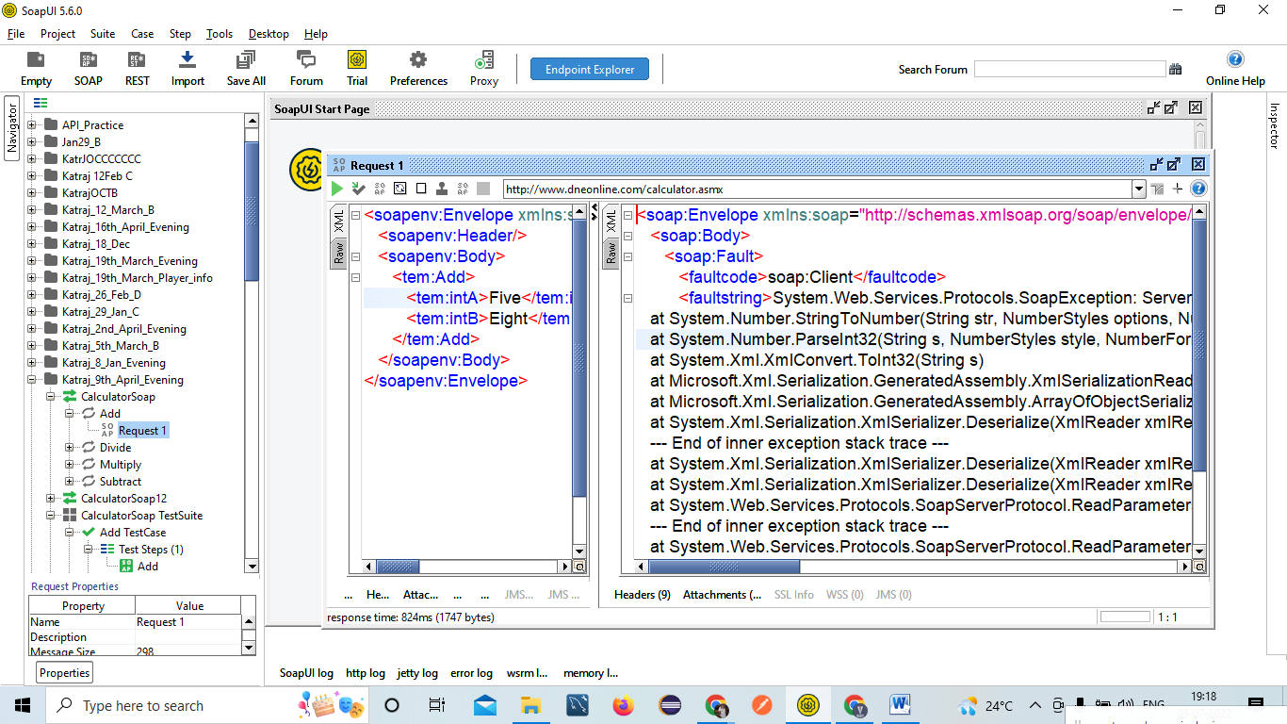

8.3 Verify the SOAP service by passing Null/Blank values🡺EC=Should not be added=Pass 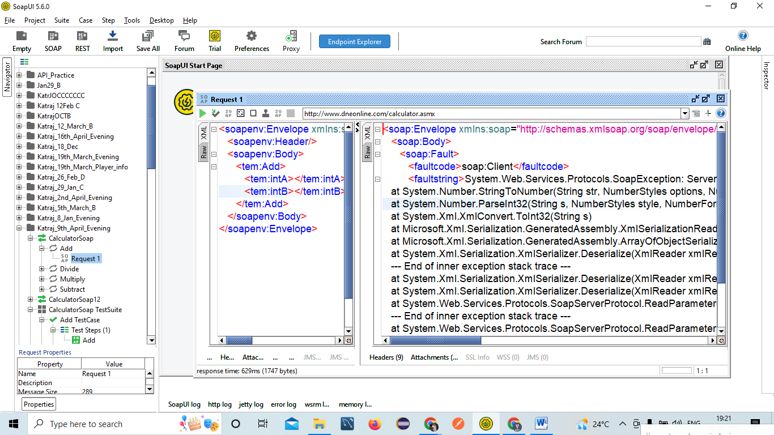

8.4 Verify the SOAP service by passing number above integer limit🡺EC=Should not be added=Pass 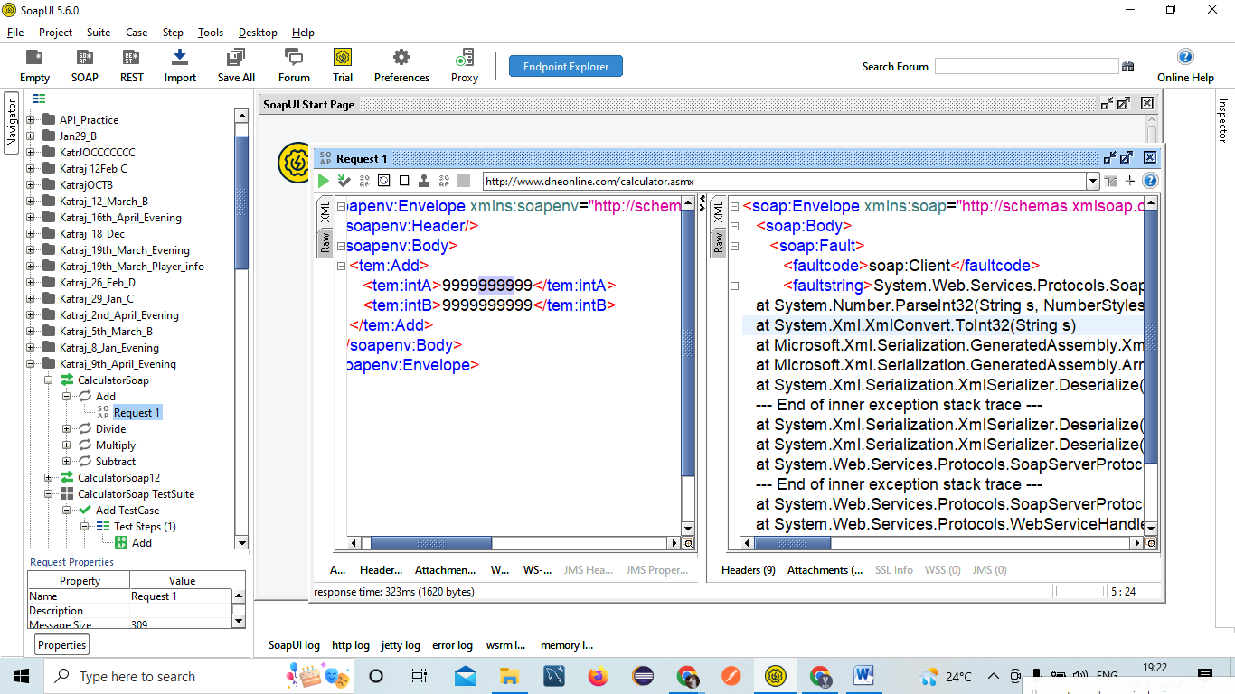

8.5 Verify the SOAP Service by passing wrong WSDL File=Pass 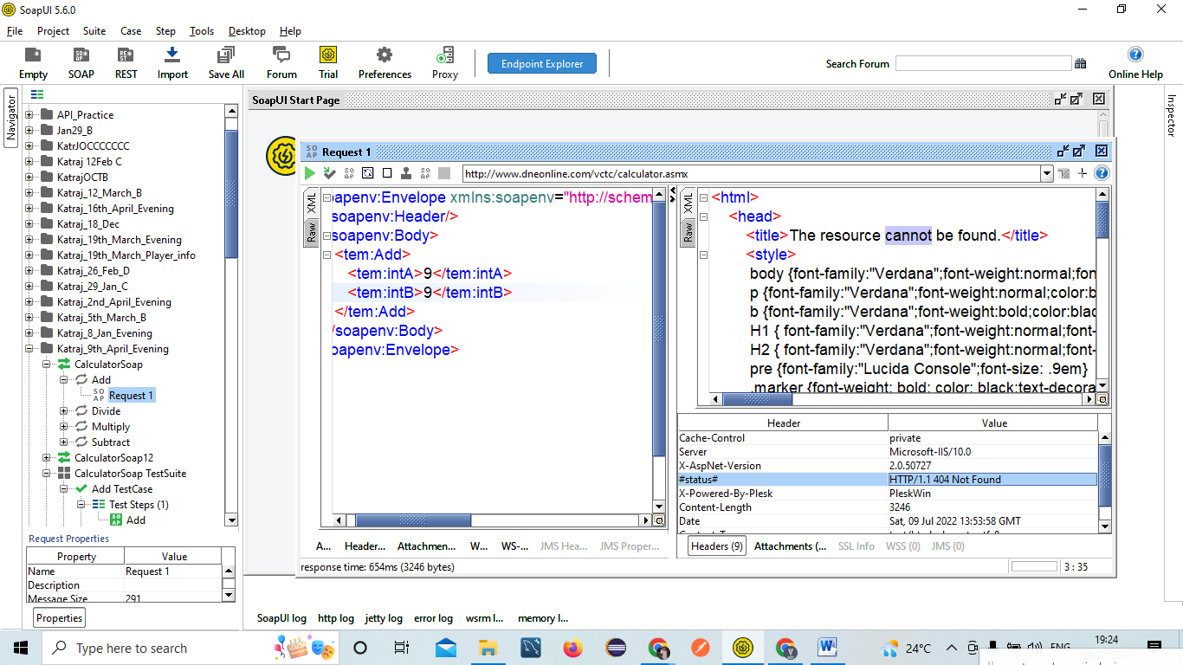

**Few Important Points:**

* How to create new SOAP Project in SOAP UI?
* How to Create test Suite in SOAP UI?
* How to Run Test Case in SOAP UI?
* How to Add Assertion in SOAP UI?

Contains

Not Contains

Valid HTTP Status Code

InValid HTTP Status Code

Response SLA

Xpath Assertion

SOAP Fault

SOAP Response

SOAP Request

Not SOAP Fault

Schema Compliance

Script Assertion

JSON Path Count

JSON Path Existence Match

JSON Path Match